Narrative
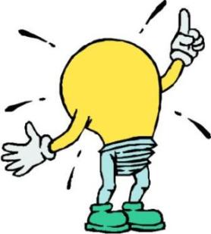
Peer Revision #1
Using the 6 Traits of Writing

Ideas: Does the paper have:
1) The character’s name? ___yes_____no
If yes, what is it? _________________________
2) Where does the story take place?
_____________________________________________________________________________

3) Does the story take place within a 24-hour time period? ____yes ____no
If not, how would you suggest they cut the amount of time?
________________________________________________________________________________________________________

4) Does the story include enough background information about the characters or situation? ____yes ____no
If no, what do you need to know more about?
________________________________________________________________________________________________________

Organization: Does the paper follow the plot triangle diagram?
Please give ONE sentence of each section of the plot triangle:
Exposition- __________________________________________________________________________________________
__________________________________________________________________________________________
Rising Action- ________________________________________________________________________________________
__________________________________________________________________________________________
Climax- __________________________________________________________________________________________
__________________________________________________________________________________________
Falling Action- _______________________________________________________________________________________
__________________________________________________________________________________________
Resolution- __________________________________________________________________________________________
__________________________________________________________________________________________

Voice: Does their paper have the following elements?:
1) Dialogue: ____yes ___no
Write down one example of their dialogue: ____________________________________________________________________________________________________________________________________________________________________________________
2) One other element? ______yes _____no
Is it a: _______metaphor? _______simile? ________ foreshadowing? _________or symbolism?
Please write down the text of this other element: ____________________________________________________________________________________________________________________________________________________________________________________
3) Is their paper told from 1st or 3rd person? _______ 1st ________ 3rd
Do they use this point of view consistently? ______yes _____no
Write down one example of text from their paper that shows which point of view they’ve used: ____________________________________________________________________________________________________________________________________________________________________________________
4) Is the story in Present or Past Tense? ______Present ______Past
Do they use this tense consistently? ______yes _____no
Write a sentence from the text that shows which tense they have written in: ____________________________________________________________________________________________________________________________________________________________________________________
Word Choice: Does the paper have the following?
1) Descriptive words? _____yes ____no
Please write down 5 of their descriptive words: ____________________________________________________________________________________________________________________________________________________________________________________
2) Do the words fit the mood of the paper? [This is a sad and serious topic] ___yes ___no
If NO, why not? ______________________________________________________________________________________

Sentence Fluency: Does the paper include?
1) Transition words? _____yes _____no
Please write down 3 transition words you noticed: ______________________________________________
2) Does the story flow from one idea to the next? Or is it choppy, jumping from thing to thing and you can’t follow the story? ______________________________________________________________
________________________________________________________________________________________________________

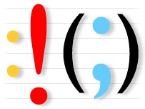
Conventions: Does the paper have the following elements?
1) Do you feel as though the narrative is long enough? ______yes _____no
How many pages is it? ___________
2) Did they skip lines and use pencil? _____yes _______no
If NO, which part is not in the correct formatting? _______________________________________________
3) Proper spelling? ______yes _____no
If NO, list a few words that are spelled incorrectly: ______________________________________________
4) Is the dialogue indented every time someone new speaks? _____yes _____no
If NOT, please mark on the paper where the indentations need to take place.

