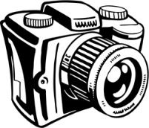
Picture That!
Cover Photo Inspiration PLANNING SHEET
Famous writers are often typically inspired by photography while they write. Karen Hesse used a picture of a young girl who actually lived in Oklahoma during the Dust Bowl to inspire her creation of the character Billie Jo Kelby in Out of the Dust. Images are powerful, and they stay with us. Successful writers create their own pictures with words, but have inspiration from their own experiences with these pictures.
What images tell your story best? Depending on what story you are telling for your narrative, you may need to bring in different types of images. For instance, if you are recalling a memory from your childhood and you have a photo of that time, you could bring in that photo for the front of your folder. Original artwork may also help in your creative process, especially if you are someone who enjoys expressing your ideas through art.
On Friday, you will get a chance to create a cover for your memoir/narrative. You are required to bring a picture, printed out illustration, or original artwork with you to class. I will supply some art supplies, but you should bring your own if you have them.
Directions: Sketch a small picture of your cover (horizontal/vertical). Be sure to include the title of your story. Indicate which pictures or images you will place where on your cover.

