Framework 4: Spelling and Vocabulary
My Test is on _____________________________
Directions: For each spelling word, complete a K.I.M. Chart on a separate piece of paper. (See the example below.) Then for Part 2, write at least one sentence for each word that explains how the word applies to English Language Arts (reading or writing). On Part 3, rewrite the word neatly at least 10 times to practice handwriting and spelling. This assignment is due on the day you have your test. Staple all pieces of paper to these directions.
- Argument
- Claim
- Credible
- Debate
- Evidence
- Analyze
- Inference
- Explicit
- Subjective
- Objective
Part 1 KIM Chart Example:
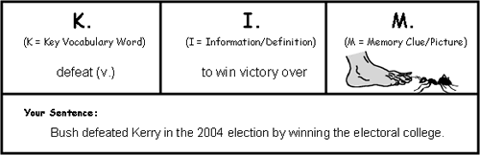
Part 2 Example Sentence: You can use the word “defeat” as a synonym that is more descriptive than “lost” or “beat”.
Part 3 Example: defeat defeat defeat defeat defeat defeat defeat defeat defeat defeat

