Stick Your Neck Out for RSMS
PROJECT DUE DATES

 Rough Draft due Thursday, April 20th
o (Exhibition Night is also this night from 6:00-7:30)
 Project Plan due Monday, April 24th
 Final Draft due Tuesday, May 2nd
 Speech Note Cards due Tuesday, May 9th
 Project Presentation Day Thursday, May 18th (This will take multiple days, but everyone needs to be ready on the 18th.)
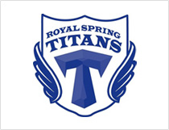

*These dates are subject to change based on any change in end of the year testing or events.

