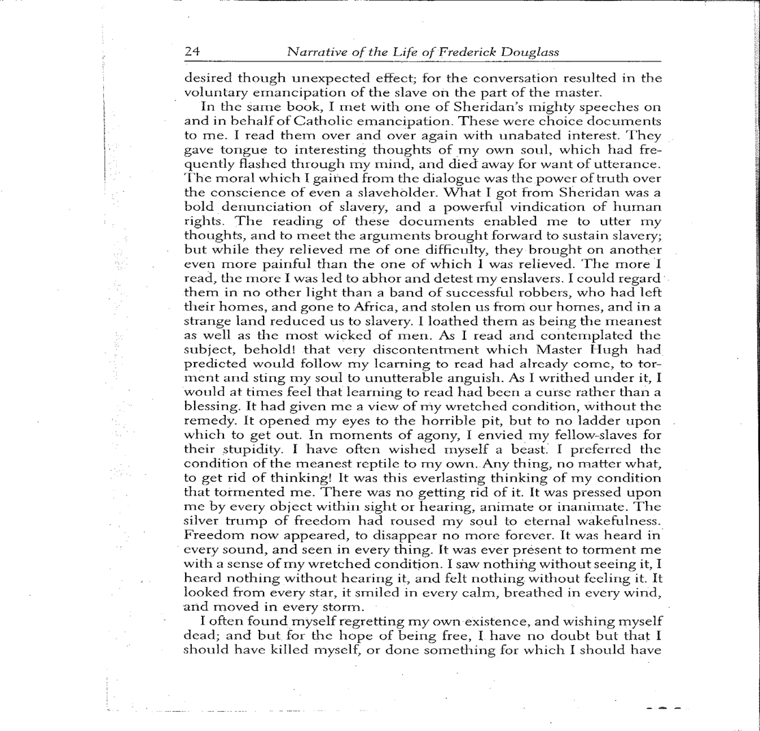
Excerpt from Narrative of the Life of Frederick Douglass

Excerpt from Long Walk to Freedom by Nelson Mandela
7th grade HOLT Elements of Literature p. 847-850

…I was not born with a hunger to be free. I was born free-free in every way that I could know. Free to run in the fields near my mother’s hut, free to swim in the clear stream that ran through my village, free to roast mealies under the starts and ride the broad backs of slow-moving bulls. As long as I obeyed my father and abided by the customs of my tribe, I was not troubled by the laws of man or God.

It was only when I began to learn that my boyhood freedom was an illusion, when I discovered as a young man that my freedom had already been taken from me, that I began to hunger for it. At first, as a student, I wanted freedom only for myself, the transitory freedoms of being able to stay out at night, read what I pleased, and go where I chose. Later as a young man in Johannesburg, I yearned for basic and honorable freedoms of achieving my potential, of earning my keep, of marrying and having a family-the freedom not to be obstructed in a lawful life.

But then I slowly saw that not only was I not free, but my brothers and sisters were not free. I saw that it was not just my freedom that was curtailed, but the freedom of everyone who looked like I did. That is when I joined the African National Congress, and that is when the hunger for my own freedom became the greater hunger for the freedom of my people. It was this desire for the freedom of my people to live their lives with dignity and self-respect that animated my life, that transformed a frightened young man into a bold one, that drove a law-abiding attorney to become a criminal, that turned a family-loving man to live like a monk. I am no more virtuous or self-sacrificing than the next man, but I found that I could not even enjoy the poor and limited freedoms I was allowed, when I knew my people were not free. Freedom is indivisible; the chains on any one of my people were the chains on all of them, the chains on all of my people were the chains on me…

Historical Narrative Compare/Contrast

Title: | Author:
Clues about the Narrator: | Evidence:
Setting: | Evidence:
Time Period: | Evidence:
Challenges: | Evidence:
Resolution: | Evidence:
Mood/Tone: | Evidence:
Unfamiliar Words/ Phrases: | Context Clues:

Historical Narrative Compare/Contrast

Title: | Author:
Clues about the Narrator: | Evidence:
Setting: | Evidence:
Time Period: | Evidence:
Challenges: | Evidence:
Resolution: | Evidence:
Mood/Tone: | Evidence:
Unfamiliar Words/ Phrases: | Context Clues:

