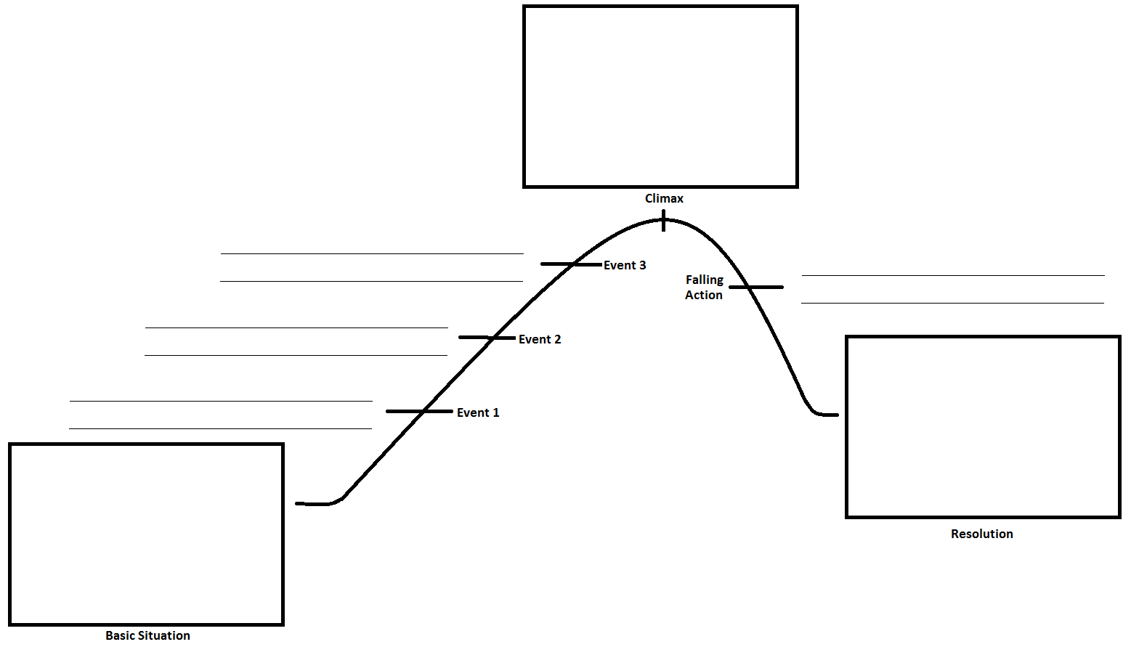

**NAME:**

Section:

Book Title:

Author:

**Complication:**

**Conflict:**

**Suspense:**

**Foreshadowing:**

***Give examples from your children’s book of each of the elements of Plot.***

***DUE at the end of class TODAY.***