A Window into World War II:
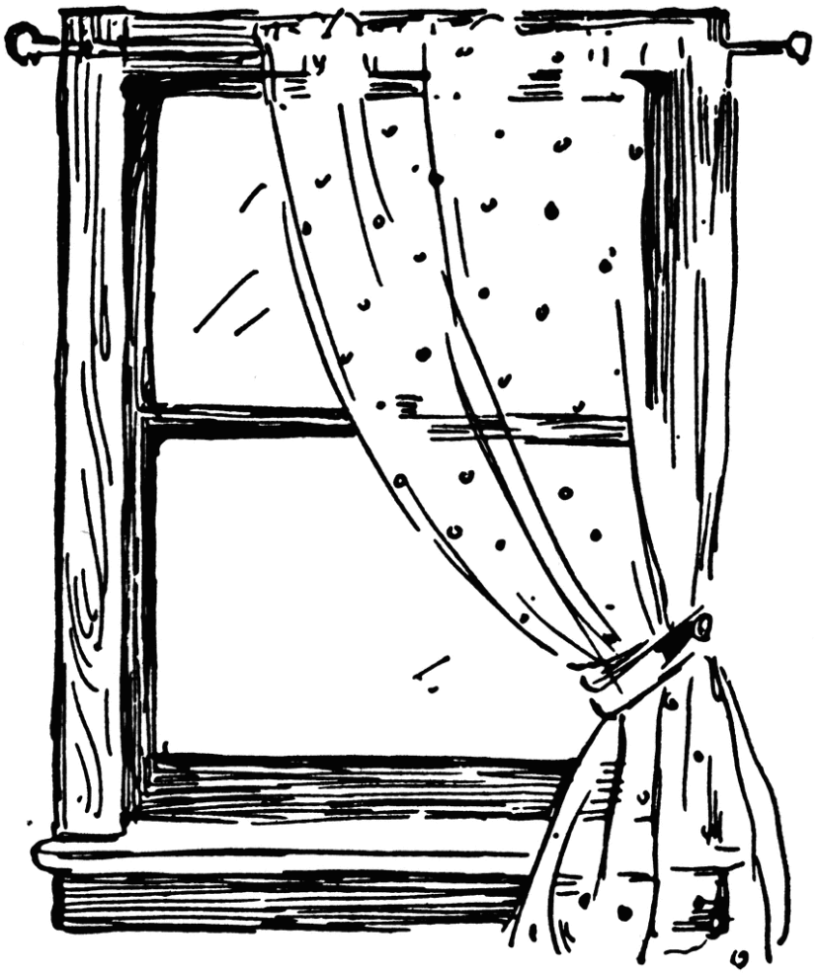
Independent Book Study alongside The Diary of Anne Frank
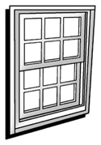
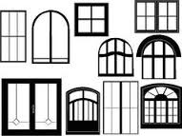

Windows allow us to see through to somewhere else, offering a new view or perspective. Anne Frank, while she was in hiding from the Nazis, wrote in a diary about her experiences during the war. Symbolically, she also was able to see a small piece of the world and find hope through a window in the attic where her family hid. Anne’s story is small, but left behind a large and memorable piece of history for us to learn from.
Directions: Find a novel or nonfiction text/sources that will allow you to gain a different view of World War II. If you choose a novel, you will complete your reading log for page numbers, etc. If you choose to investigate a particular context of history, you must provide at least 10 credible nonfiction sources.
Then create a “window” to display your knowledge of this time and of the book or context you studied. Complete all 4 parts. You may choose to put these on an actual window, create a poster window, or create a digital window through power point or any other media.
Part 1: QUOTE JOURNAL – Copy 3 significant quotes from your book. Then in 2-3 sentences, describe the significance of these quotes. How do they help you understand the time period better? How are they significant to the text as a whole?
Part 2: IMAGE – Display 3 images that represent the most important pieces of your book or historical context. Be sure to caption your image in at least a sentence and provide credit for the source where you found it.
Part 3: 3.8 PARAGRAPH – Write a 3.8 in which you compare/contrast your book’s view or historical perspective of World War II to the view presented in The Diary of Anne Frank.
Part 4: HISTORICAL TIMELINE – Create a timeline that shows important events that were listed in your book/time period on one side. On the other side, show important events from Anne’s life. This may require research of the time period online or at the library.
Window Project | The student has put their name and class period on the project somewhere. | +_____ / 2
 | Title and Author of book displayed  OR List of researched sources (at least 10)  Include an MLA formatted Works Cited. | +_____ / 2
 | The project shows that the student has put effort and thought into how they completed the parts. The display is neat and organized. | +_____ / 10
Part 1: QUOTE JOURNAL | The student has 3 quotes from their book or sources. The lines from the book/source are in quotations with the page numbers given or author of the source. | + _____ / 9
 | The student wrote 2-3 sentences describing the quotes’ significance, how it helped them better understand the time period, and how they are significant to the book as a whole or the historical context. | + _____ / 9
Part 2: IMAGE | The student has selected 3 significant images to represent their book/ historical context. | +_____ / 3
 | The student wrote captions for their pictures in a complete sentence, describing the image. | + _____ / 3
 | The student gave credit for the source where they received the images. | + _____ / 3
Part 3:  3.8 Paragraph | The student compared and contrasted the views presented from The Diary of Anne Frank to the view and information presented in their book or sources of historical context. | + _____ / 13
 | The student indented the paragraph. | + _____ / 2
 | The student wrote in complete sentences with punctuation that was grammatically correct. | + _____ / 5
 | The student used at least one direct quote from a text to support a main point made. | + _____ / 2
 | The student used both titles of the books (or mentioned the historical context comparison) in the 1st sentence assertion. | + _____ / 2
Part 4: TIMELINE | The student showed at least 5 important historical events that occurred during Anne Frank’s story. | + _____ / 5
 | The student displayed at least 5 important historical events that occurred during the book they read. | + _____ / 5

TOTAL: _____ / 75 points

